**Essentials of Generative AI, Prompt Engineering, and ChatGPT**

Course End Project Problem Statement

**Course End Project: ChatGPT-Based Storytelling**

### Problem Scenario: Create an interactive storytelling adventure using ChatGPT, where you can create unique and engaging narratives without requiring any coding or additional platforms.

**Problem Objective:** Unleash your creativity and storytelling abilities by using ChatGPT as a tool to collaboratively build an interactive story.

**Solution**

1. **Screen Shot of ChatGPT Prompt**

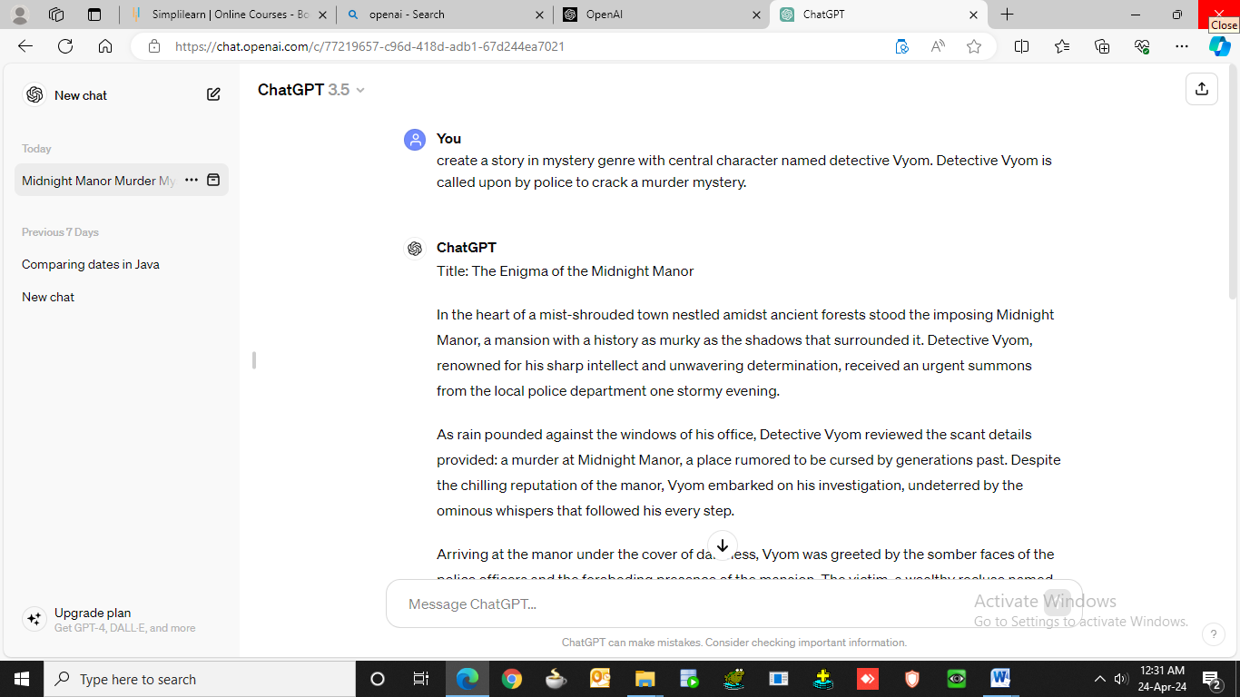

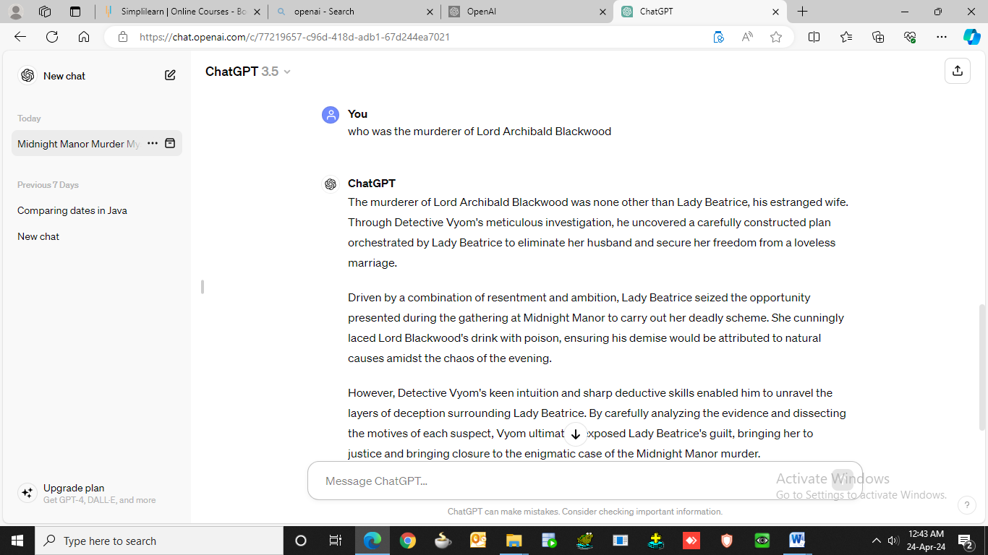

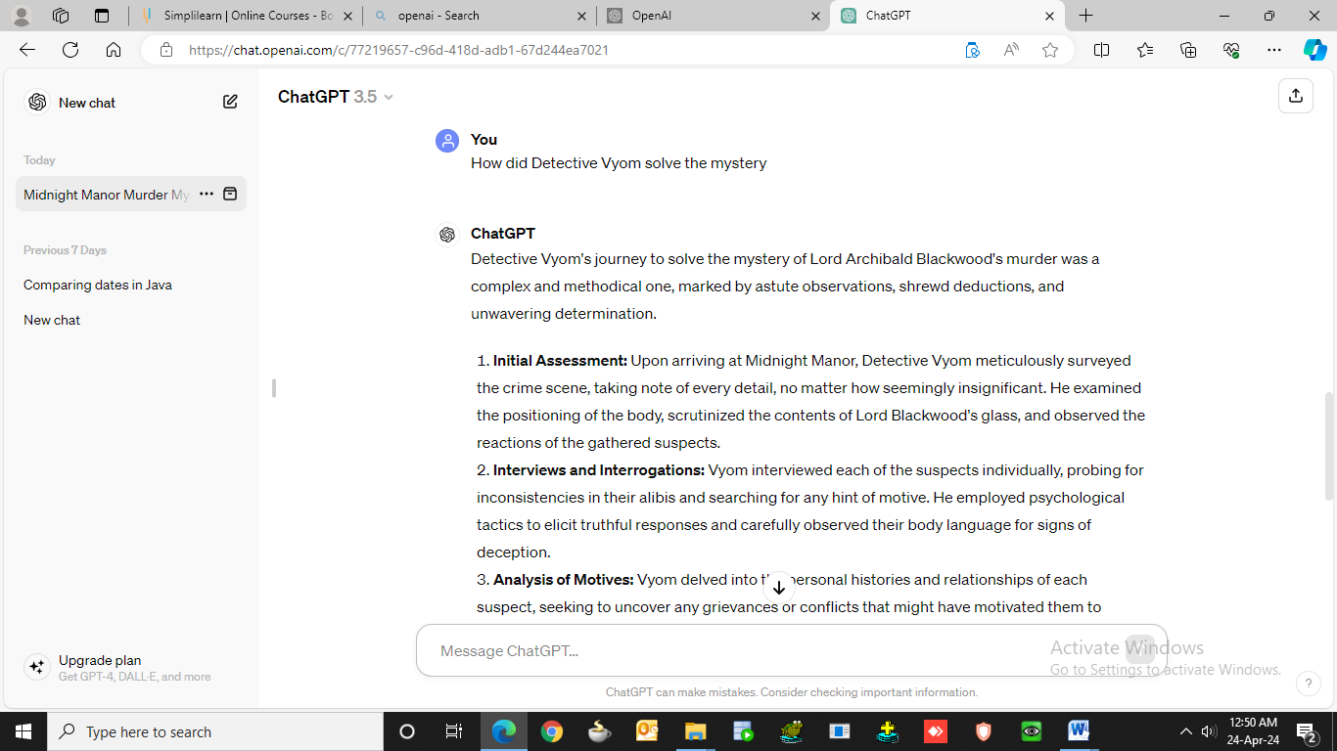

1. **Generated and Compiled Content**

**Title: The Enigma of the Midnight Manor**

In the heart of a mist-shrouded town nestled amidst ancient forests stood the imposing Midnight Manor, a mansion with a history as murky as the shadows that surrounded it. Detective Vyom, renowned for his sharp intellect and unwavering determination, received an urgent summons from the local police department one stormy evening.

As rain pounded against the windows of his office, Detective Vyom reviewed the scant details provided: a murder at Midnight Manor, a place rumoured to be cursed by generations past. Despite the chilling reputation of the manor, Vyom embarked on his investigation, undeterred by the ominous whispers that followed his every step.

Arriving at the manor under the cover of darkness, Vyom was greeted by the somber faces of the police officers and the foreboding presence of the mansion. The victim, a wealthy recluse named Lord Archibald Blackwood, was found lifeless in the grand ballroom, surrounded by a group of guests who all claimed innocence.

Vyom meticulously examined the crime scene, his keen eyes discerning details that eluded even the most experienced investigators. Traces of poison were discovered in Lord Blackwood's glass, leading Vyom to suspect foul play. However, the question remained: who among the guests had the motive and opportunity to commit such a heinous act?

Interviewing each suspect, Vyom uncovered a web of secrets, lies, and long-held grudges concealed beneath the facade of civility. Lady Beatrice, the estranged wife of the deceased, harboured resentment for her husband's infidelities. Sir Reginald, a business rival, stood to gain control of Blackwood's vast fortune. And Miss Evelyn, the enigmatic governess, bore a mysterious connection to the manor's tragic past.

With each revelation, Vyom pieced together the puzzle, drawing closer to unravelling the truth behind Lord Blackwood's demise. As tensions mounted and suspicions ran rampant, Vyom orchestrated a dramatic confrontation in the manor's candlelit halls, exposing the murderer's identity in a stunning climax that left even the most jaded observers astonished.

Detective Vyom's journey to solve the mystery of Lord Archibald Blackwood's murder was a complex and methodical one, marked by astute observations, shrewd deductions, and unwavering determination.

1. **Initial Assessment**: Upon arriving at Midnight Manor, Detective Vyom meticulously surveyed the crime scene, taking note of every detail, no matter how seemingly insignificant. He examined the positioning of the body, scrutinized the contents of Lord Blackwood's glass, and observed the reactions of the gathered suspects.

2. **Interviews and Interrogations**: Detective Vyom interviewed each of the suspects individually, probing for inconsistencies in their alibis and searching for any hint of motive. He employed psychological tactics to elicit truthful responses and carefully observed their body language for signs of deception.

3. **Analysis of Motives**: Vyom delved into the personal histories and relationships of each suspect, seeking to uncover any grievances or conflicts that might have motivated them to commit murder. He explored the tangled web of emotions and rivalries that existed within the confines of Midnight Manor, recognizing that the key to solving the mystery lay in understanding the hearts and minds of those involved.

4. **Evidence Examination**: Vyom meticulously analysed the physical evidence recovered from the crime scene, from the poison-laced glass to any fingerprints or other forensic traces. He cross-referenced this evidence with the testimonies of the suspects, searching for any inconsistencies or discrepancies that might reveal the truth.

5. **Connecting the Dots**: As Vyom pieced together the fragments of evidence and information gathered throughout his investigation, he began to discern a pattern emerging. He identified subtle clues and overlooked details that pointed towards the true culprit, weaving together a narrative that explained the sequence of events leading up to Lord Blackwood's murder.

6. **Confrontation and Resolution**: Armed with his newfound insights, Detective Vyom orchestrated a dramatic confrontation with the suspects, presenting his evidence and confronting them with the truth. Through his masterful interrogation techniques and keen powers of deduction, Vyom ultimately compelled the guilty party to confess, bringing closure to the case and delivering justice for the victim.

In the end, it was Detective Vyom's unwavering dedication to uncovering the truth, coupled with his sharp intellect and keen intuition that enabled him to solve the mystery of the Midnight Manor murder and bring the perpetrator to justice.

The murderer of Lord Archibald Blackwood was none other than Lady Beatrice, his estranged wife. Through Detective Vyom's meticulous investigation, he uncovered a carefully constructed plan orchestrated by Lady Beatrice to eliminate her husband and secure her freedom from a loveless marriage.

Driven by a combination of resentment and ambition, Lady Beatrice seized the opportunity presented during the gathering at Midnight Manor to carry out her deadly scheme. She cunningly laced Lord Blackwood's drink with poison, ensuring his demise would be attributed to natural causes amidst the chaos of the evening.

However, Detective Vyom's keen intuition and sharp deductive skills enabled him to unravel the layers of deception surrounding Lady Beatrice. By carefully analysing the evidence and dissecting the motives of each suspect, Vyom ultimately exposed Lady Beatrice's guilt, bringing her to justice and bringing closure to the enigmatic case of the Midnight Manor murder.

In the end, justice prevailed, and the shadow of suspicion lifted from Midnight Manor. As Detective Vyom bid farewell to the haunting estate, he carried with him the satisfaction of solving yet another mystery, his name destined to be whispered in awe and admiration for years to come.

Linked In URL: https://www.linkedin.com/pulse/enigma-midnight-manor-anand-shanker-misra-gdxac